1. Profit is maximum when all 50 TV sets are sold.

On a 7-day promotion, to have maximum profits the sales should be according to the demand. The total probability of selling all the TVs is cumulative sum of each day demand probability, which is, 0.85.

Hence, the TV sets to be sold for maximum profit = 50 * 0.85 ~ 43 sets

1. From the excel sheet solution, the maximum mean and median of profit occurs for 21 sets of TVs for 5 set (attached as ‘Problem 12.15b_5iterations’) and 10 set (attached as ‘Problem 12.15b_10iterations’) iterations.

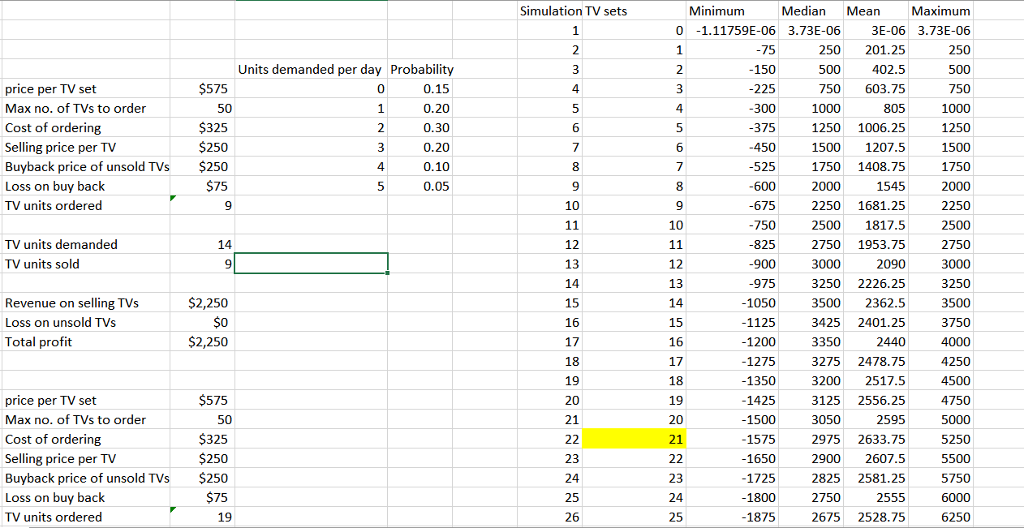



Hence expected profit = 21 * (TV sets price – ordering cost) = 21 * (575-325) = $5250

1. If surplus dealer buys only 4 TV sets, the model will change and different results are obtained as shown in figure below (attached as ‘Problem 12.15c’)

The highlighted portion gives the maximum mean, median and psimax combination for the model on 14 TV sets of stock and the profit in this situation is 14*250 = $3500

